**INDUSTRIAL TRAINING REPORT**

SUBMITTED IN PARTIAL FULFILLMENT OF THE REQUIREMENT FOR

Six Week Industrial Training

at

**DK UNICARE A SOFTWARE SOLUTION PVT LTD**

**(From JUNE to JULY 2015)**

**SUBMITTED BY**

**Mohit Kumar**

G:\mohit\SJPP\photos\fronttop.jpg

**Department of Computer Science**

**SETH JAI PARKASH POLYTECHNIC COLLAGE**

**DAMLA**

**PREFACE**

Learning comes from doing. To learn something one has to go through practical conditions.

Recognizing this fact, Haryana Technical University has made it mandatory for DIPLOMA students to undergo an Industrial Training during the last semester of the course. During this period, the students get a first hand exposure towards the functioning of the organization and the actual environment.

This project report was prepared during the training period in DK UNICARE (INDIA) PRIVATE LIMITED. During this period, an effort was made to understand the development Operations of various Applications developed by DK UNICARE (INDIA) PRIVATE LIMITED. This report lays special emphasis on the operational work, tasks and projects carried out during the training period.

**ACKNOWLEDGEMENT**

Acknowledgement is not a more formality but a genuine opportunity to thank all those people because without their support this project would not be possible.

I am highly grateful to **Er. Sanjeev sahegal (HOD, Deptt of Computer** **Science, Seth Jai Parkash Polytechnic, Damla)** for constant guidance and encouragement.

I would like to express a deep sense of gratitude and thanks profusely to **Miss. Santi Kakker (PHP developer and trainee)** of Company. Without the wise counsel and able guidance, it would have been impossible to complete the report in this manner.

I also express gratitude to other faculty members of the Department of Computer Science, SSSETC Gurdaspur for their intellectual support throughout the course of this work.

Finally, I am indebted to all whosoever have contributed in this report work and friendly stay at **DKUNICARE A SOFTWARE SOLUTION PVT LTD.**

MOHIT KUMAR

**TABLE OF CONTENT**

|  |  |  |
| --- | --- | --- |
| **S.no** | **Topic** | **Page no.** |
| **CHAPTER 1** | 1.1 Company Profile  1.2 Project tools  1.2.1 Introduction to HTML  1.2.2 Introduction to CSS  1.2.3 Introduction to JavaScript  1.2.4 Introduction to PHP  1.2.5 Introduction to Photoshop  1.2.6 Introduction to Word press  1.2.7 Introduction to My Sql | 1  3  4  6  9  11  14  16  18 |
| **CHAPTER 2** | 2.1 Introduction to Wamp server  2.2 Introduction to Dreamweaver | 21  23 |
| **CHAPTER 3** | Introduction to project and its values | 25 |
| **CHAPTER 4** | Modules of Project | 29 |
| **CHAPTER 5** | Table structures | 31 |
| **CHAPTER 6** | 6.1 Data flow diagrams  6.2 ER Diagrams | 35  38 |
| **CHAPTER 7** | Snapshots | 44 |
| **CHAPTER 8** | Conclusion and Bibliography | 53 |

**CHAPTER 1**

1.1 Company Profile

The concerned project is to be developed under the supervision and guidance of employees of company namely DKUNICARE A SOFTWARE SOLUTION Pvt. Ltd. This company has been located at 4th floor, Phase-6 Industrial Area, Near GOLD GYM Mohali (Punjab). Ph.: 0172-4638606, 5091855, M: 9815216606.

**DK UNICARE A SOFTWARE SOLUTION PVT LTD.**

# DK Unicare A Software Solution Pvt. Ltd. is a Multi Domain Organization, covering almost all major trends of modern day technology. Eureka ElectroSoft Solutions Pvt. Ltd. (EESPL) is primarily operating as a registered R & D lab for the development and conception of Advanced Automation related software and hardware solutions. Their expertise includes electronics and software based stand alone solutions as well as combined integrated solutions termed as “Electrosoft Solutions”.

# logo

# EESPL - The Background and Essence of Operations

The year 2002 witnessed the birth of a visualization – which was to impart economy with a pinnacle swiftness of innovation in contemporary Industrial IT Solutions. There came EESPL and a new chapter of imparting excellence in IT techniques came into subsistence.

# Vision & Mission

Their corporate vision is to provide a fully functional IT platform to all complex tasks thereby inducing a greater sense of effectiveness and to consistently create value for money, by providing solutions which enable the customers to achieve excellence and sustainable competitive edge.

# Mission Target

Their mission statement is to provide endearing technologies of future in the present era and for that they are committed to develop innovative and the most valuable solutions to their customers as their motto is "Changing Ideas into Reality".

# Quality Testing

Quality Assurance is one of the key focus areas and once a solution is developed, their Software Testing Team steps in to perform the rigorous rituals, required to deliver a robust, flawless product/application. Software testing at Olive is performed at several points in the Software Development Life Cycle (SDLC), as an application is constructed component by component into a functioning system. Their qualified testers carry out intense testing for bugs and flaws and fix the same - all within the strictest time frame.

**1.2 PROJECT NAME: Online Exam Application**

**TOOLS TO BE USED**

Front End Tools:

1. HTML

2. CSS

3. JAVASCRIPT

4. PHP 5.3.1

5. ADOBE PHOTOSHOP

6. WORDPRESS

Back End Tools:

1. MY SQL 5.5.24

**1.2.1 INTRODUCTION TO HTML**

**Hyper Text Markup Language** commonly referred to as HTML is the standard markup language used to create web pages, Hypertext means machine readable text and Markup means to structure it in a specific format. It is written in the form of HTML elements consisting of tags enclosed in angle brackets (like <html>). HTML tags most commonly come in pairs like <h1> and </h1>, although some tags represent empty elements and so are unpaired, for example <img>. The first tag in a pair is the start tag, and the second tag is the end tag.

Web browsers can read HTML files and compose them into visible or audible web pages. Browsers do not display the HTML tags and scripts, but use them to interpret the content of the page. HTML describes the structure of a website semantically along with cues for presentation, making it a markup language, rather than a programming language.

HTML elements form the building blocks of all websites. HTML allows images and objects to be embedded and can be used to create interactive forms. It provides a means to create structured documents by denoting structural semantics for text such as headings, paragraphs, lists, links, quotes and other items. It can embed scripts written in languages such as JavaScript which affect the behavior of HTML web pages.HTML is the most common used language to write web pages. HTML elements form the building blocks of all websites. HTML allows HTML element to be embedded and can be used to create Fieldset. It provides a means to create document by denoting structural semantics for text such as headings, paragraphs, lists, Hyperlink, quotes and other items. It can embed Scripting language written in languages such as JavaScript which affect the behavior of HTML web pages.

It has recently gained popularity due to its features such as : -

1. It is the language which can be easily understand and can be modified.
2. Effective presentations can be made with the HTML with the help of its all formatting tags.
3. It provides the more flexible way to deign web pages along with the text.
4. Links can also be added to the web pages so it help the readers to browse the information of their interest.
5. You can display HTML documents on any platforms such as Macintosh, Windows and Linux etc.
6. Graphics, videos and sounds can also be added to the web pages which give an extra attractive look to your web pages.

**1.2.2 INTRODUCTION TO CSS**

Cascading Style Sheets (CSS) is a style sheet language used for describing the look and formatting of a document written in a markup language. While most often used to change the style of web pages and user interfaces written in HTML and XHTML, the language can be applied to any kind of XML document, including plain XML, SVG and XUL. Along with HTML and JavaScript, CSS is a cornerstone technology used by most websites to create visually engaging webpages user interfaces for web applications, and user interfaces for many mobile applications.

CSS is designed primarily to enable the separation of document content from document presentation, including elements such as the layout, colors, and fonts. This separation can improve content accessibility, provide more flexibility and control in the specification of presentation characteristics, enable multiple HTML pages to share formatting by specifying the relevant CSS in a separate .css file, and reduce complexity and repetition in the structural content, such as semantically insignificant tables that were widely used to format pages before consistent CSS rendering was available in all major browsers.

**Types of css:-**

* Inline Style Sheet:- An inline style may be used to apply a unique style for a single element. An inline style loses many of the advantages of a style sheet (by mixing content with presentation).To use inline styles, add the style attribute to the relevant tag. The style attribute can contain any CSS property.
* Internal Style Sheet:- An internal style sheet may be used if one single page has a unique style. Internal styles are defined within the <style> element, inside the head section of an HTML page.
* External Style Sheet:-  With an external style sheet, you can change the look of an entire website by changing just one file. Each page must include a reference to the external style sheet file inside the <link> element. The <link> element goes inside the head section. An external style sheet can be written in any text editor. The file should not contain any html tags. The style sheet file must be saved with a .css extension.

**Features of CSS**

**1. CSS Animations and Transitions**

CSS animations are finally available in all major browsers, even in IE. There are two ways to create CSS animations. The first is very easy it is done through animating the changes of CSS properties with the transition declaration. With transitions, you can create hover or mouse down effects, or you can trigger the animation by changing the style of an element with JavaScript. You can see the transition below by hovering over the planet – this will cause the rocket to close in.

**2. Advanced Selectors**

These days, if you assign IDs to elements only so you can style them, you are probably doing it wrong. CSS 2.1 and CSS 3 introduced a number of powerful selectors that can make your layouts cleaner, and your stylesheets more awesome.

**3. Generated Content and Counters**

Generated content is a powerful tool in the hands of developers, made available by the before and after pseudo elements. This feature lets you use less HTML to achieve the same layouts. This is especially beneficial in cases where you need extra box shadows or other visual elements that would require extra spans or divs. In the end, you get a more minimal and semantically correct HTML.

CSS3 also gives pseudo elements access to counters, which can be incremented with a CSS rule. They can also access attributes from the parent elements that contain them. See the source of the example below.

**4. Webfonts**

Can you imagine that there was a time when we were limited to only a handful of “web-safe” fonts and nothing else? It is hard to believe, given that today we have services like Google Fonts and typekit, which let you embed beautiful fonts by simply including a stylesheet in your page. There are even icon fonts like font awesome, which contain pretty vector icons, instead of letters or numbers. This was all made possible by the @font-face rule, which lets you define the name, characteristics and source files for fonts, which you can later refer in your font/font-family declarations.

**5. Box Sizing**

The single biggest cause for headaches for CSS beginners is the box model. The standardization bodies have probably had their reasons, but it doesn’t feel at all intuitive to have the CSS width and height of an element affected by its padding and borders. This little (mis)feature breaks layouts and wreaks havoc, but finally there is a way to restore our sanity by using the box-sizing rule. You can set it to border-box, which makes elements behave exactly the way you expect. See for yourself:

**1.2.3 INTRODUCTION TO JAVASCRIPT**

JavaScript is an object (Object)-based and event-driven (Event Driven) and safety performance scripting language. Its purpose is to use HTML and HTML, Java scripting language (Java applet) to connect multiple objects in a Web page, the interaction with the Web client. It can develop the client application. It is realized by embedding or transferred to a standard HTML language. It appears to make up for the deficiencies of the HTML language, Java and HTML compromise choice, has the following basic characteristics:

**1. It is a scripting language**

JavaScript is a scripting language that is small block programming. Like other scripting languages, JavaScript is an interpreted language, it provides an easy development process. Its basic structure is very similar to C, C + +, VB, Delphi. But unlike these languages, you need to compile, but the program is running progressive explained, together with HTML markup, and user-friendly operation.

**2. Object-based language**

JavaScript is an object-based language, and can be seen as an object-oriented. This means that it can use the objects they have created. Therefore, many functions can be derived from the method of an object in the scripting environment and the interaction of the script.

**3. A simple**

JavaScript simplicity is mainly reflected in: First, it is based on a simple and compact design of the Java basic statements and control flow and thus for learning Java is a very good transition. Followed by the type of variable it is weakly typed, did not use strict data typing.

**4. The security**

JavaScript is a language of security, it does not allow access to the local hard disk, does not bring the data into the server, network documentation is not allowed to modify, and delete information browsing or dynamic interaction can only be achieved through the browser, So as to effectively prevent the loss of data.

**5. The dynamic**

JavaScript is dynamic, it can be directly on the user or customer input to respond without going through the Web service program. Its a reflection of the user's response, is the use of event-driven manner. The so-called event-driven, that is, the operation of some operation is performed in the Home page (Home Page), referred to as "events" (Event). Such as pressing the mouse, move the window, select the menu and so can be regarded as an event. When the event occurs, it may cause the the corresponding incident response.

**6. Cross-platform**

JavaScript is dependent on the browser itself, regardless of the operating environment, as long as the computer running the browser and JavaScript-capable browser can execute correctly. In order to achieve the dream of "write once, run everywhere". In fact, the most excellent JavaScript that can be used to do a lot of things in a very small program. Without high-performance computers, software is just a word-processing software and a browser, without WEB server channel, you can do everything through their own computer.

**1.2.4 INTRODUCTION TO PHP**

PHP which stands for "PHP: Hypertext Preprocessor" is a widely-used Open Source general-purpose scripting language that is especially suited for Web development and can be embedded into HTML. Its syntax draws upon C, Java, and Perl, and is easy to learn. The main goal of the language is to allow web developers to write dynamically generated web pages quickly, but you can do much more with PHP.

PHP is a server side scripting language designed for web development but also used as a General-purpose programming language.PHP is now installed on more than 244 million Website and 2.1 million Web server.PHP code is Interpreter by a web server with a PHP processor module, which generates the resulting web page: PHP commands can be embedded directly into an HTML source document rather than calling an external file to process data.

The PHP interpreter only executes PHP code within its Delimiter. Anything outside its delimiters is not processed by PHP (although non-PHP text is still subject to Control structure described in PHP code). The most common delimiters are <?php to open and ?> to close PHP sections. <script language="php"> and </script> delimiters are also available, as are the shortened forms <? or <?= (which is used to echo back a String or Variable) and ?> .

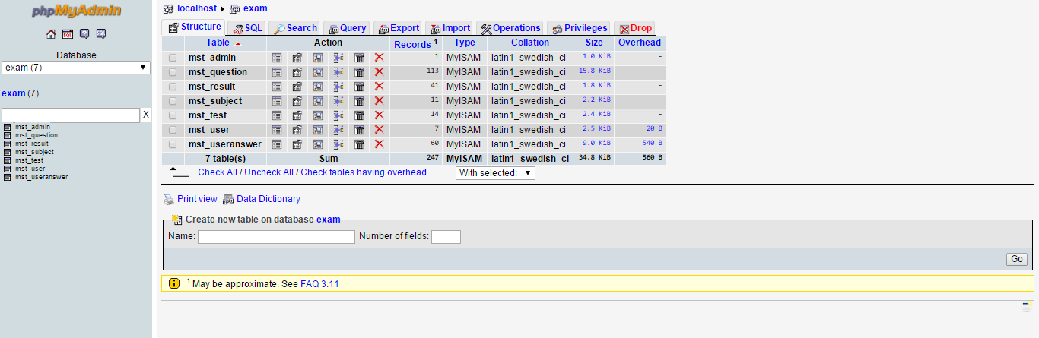

**Fig 1.phpMyAdmin**

**FEATURES OF PHP:**

# HTTP authentication with PHP:- It is possible to use the header() function to send an"Authentication Required" message to the client browser causing it to pop up a Username/Password input window. Once the user has filled in a username and a password, the URL containing the PHP script will be called again with the predefined variables.

* **Cookies:-** PHP transparently supports HTTP cookies. Cookies are a mechanism for storing data in the remote browser and thus tracking or identifying return users. You can set cookies using the setcookie() or setrawcookie() function. Cookies are part of the HTTP header, so setcookie() must be called before any output is sent to the browser. This is the same limitation that header() has.
* **Session:-** Session support in PHP consists of a way to preserve certain data across subsequent accesses. This enables you to build more customized applications and increase the appeal of your web site.
* **File Handling:-** This feature lets people upload both text and binary files. With PHP's authentication and file manipulation functions, you have full control over who is allowed to upload and what is to be done with the file once it has been uploaded.
* **Using remote files:**- As long as **allow_url_fopen** is enabled in php.ini, you can use HTTP and FTPURLs with most of the functions that take a filename as a parameter. In addition, URLs can be used with the include, include-once, require and require-once statements.
* **Persistent Database Connections:**- Persistent connections are links that do not close when the execution of your script ends. When a persistent connection is requested, PHP checks if there's already an identical persistent connection (that remained open from earlier) - and if it exists, it uses it. If it does not exist, it creates the link. An 'identical' connection is a connection that was opened to the same host, with the same username and the same password (where applicable).

**1.2.5 INTRODUCTION TO ADOBE PHOTOSHOP**

Photoshop is a graphics based program created with images known as raster graphics. Other graphic applications, i.e. Illustrator, Corel Draw and Freehand, create vector graphics. Vector graphics are composed of solid lines, curves and other geometric shapes that are defined by a set of mathematical instructions. Vector images work best for type and other shapes that require clear crisp boundaries. Raster images work best with photographs. Raster graphics are comprised of a raster (a grid) of small squares called pixels. Objects in Photoshop are groups of many pixels – each of which can be a different color. Raster images require more memory and storage than vector images. Photoshop is a memory-hungry program. This class will introduce you to the tool palette, basic commands, common menus, layers and how to make selections based on shape and color. Adobe Photoshop is an advanced photo-manipulation tool. Using its many powerful tools and options may seem complex at the start. This workshop familiarises the beginner with the basic palette of tools, concepts and terminology that Photoshop uses. The focus is on learning the eight most helpful techniques and procedures for using Photoshop and improving and manipulating scanned and digitally photographed images.

**Image Resolution and format:** Digital Images are represented in pixels. Image resolution refers to the number of pixels in the image and is measured in pixels per inch. The more pixels per square inch, the higher the resolution.

Photoshop files have default file extension as **.PSD** which stands for "Photoshop Document." A PSD file stores an image with support for most imaging options available in Photoshop. These include layers with Mask , transparency, text, alpha channel  and Spot color, Clipping_path, and Duotone settings. This is in contrast to many other file formats (e.g. .JPG or .GIF) that restrict content to provide streamlined, predictable functionality. A PSD file has a maximum height and width of 30,000 pixels, and a length limit of 2 Gigabytes.

Photoshop files sometimes have the file extension **.PSB**, which stands for "Photoshop Big" (also known as "large document format"). A PSB file extends the PSD file format, increasing the maximum height and width to 300,000 pixels. The dimension limit was apparently chosen arbitrarily by Adobe, not based on computer arithmetic constraints (it is not close to a power of two, as is 30,000) but for ease of software testing. PSD and PSB formats are documented.

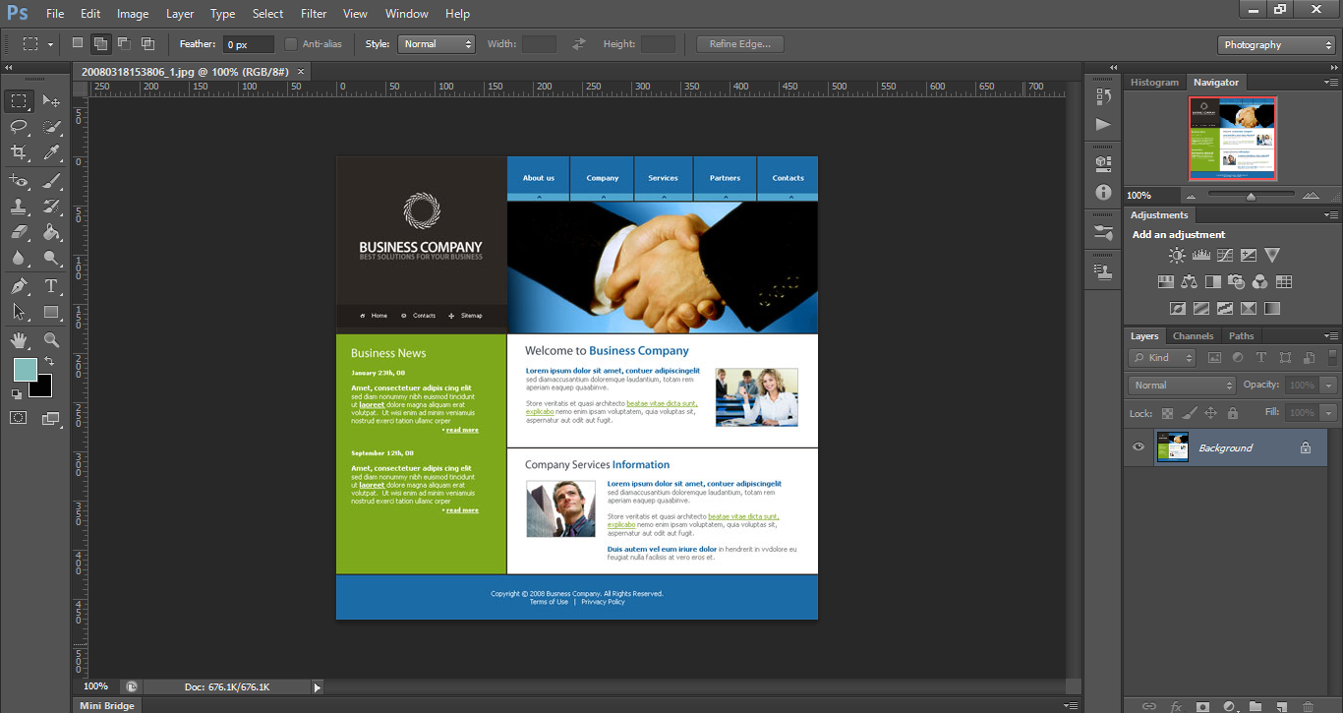

**Fig 2.Adobe Photoshop**

**1.2.6 INTRODUCTION TO WORDPRESS**

**WordPress** is a Free and open-source software and Blogging tool and a Content management system (CMS) based on PHP and MySQL. Features include a plug-in architecture and a template system.

Word Press users may install and switch between themes. Themes allow users to change the look and functionality of a Word Press website and they can be installed without altering the content or health of the site. Every Word Press website requires at least one theme to be present. Every Word Press theme should be designed using some standards with structured PHP, valid HTML and css..

The PHP, HTML (Hypertext Markup Language) and CSS (Cascading Style Sheets) code found in themes can be added to or edited for providing advanced features. Word Press themes are in general classified into two categories, free themes and premium themes. Word Press users may also create and develop their own custom themes if they have the knowledge and skill to do so.

Word Press users may install and switch between themes. Themes allow users to change the look and functionality of a Word Press website or installation without altering the information content or structure of the site. Themes may be installed using the Word Press "Appearance" administration tool or theme folders may be uploaded via FTP.

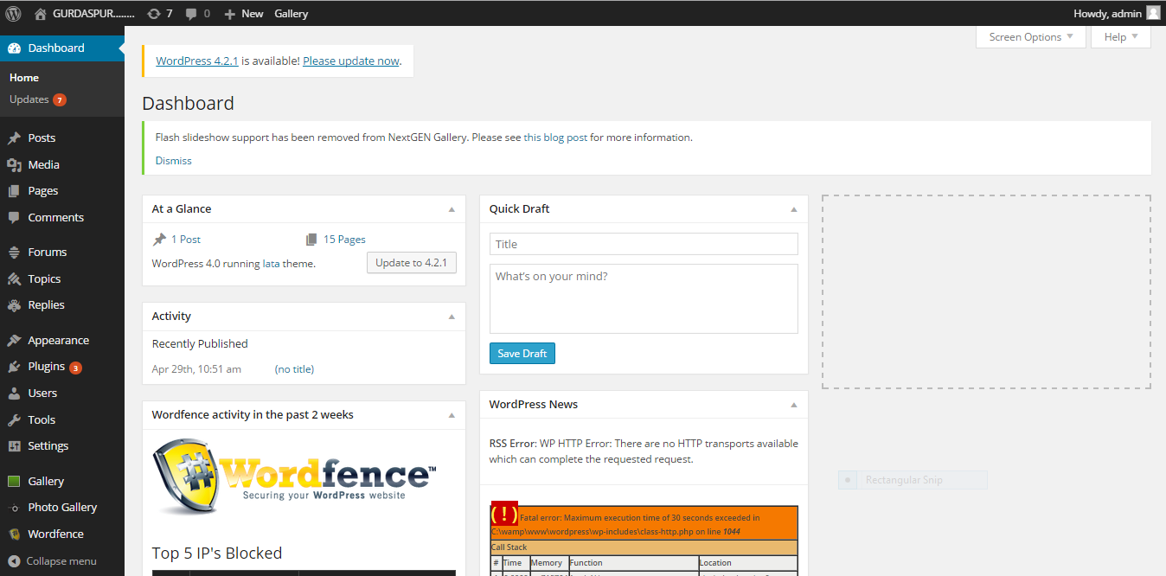

**Fig 3. Wordpress**

**1.2.7 MY SQL**

MySQL is currently the most popular open source database server in existence. On top of that, it is very commonly used in conjunction with PHP scripts to create powerful and dynamic server-side applications. MySQL is a fast, easy-to-use RDBMS being used for many small and big businesses. MySQL is developed, marketed, and supported by MySQL AB, which is a Swedish company. MySQL is becoming so popular because of many good reasons:-

* MySQL is released under an open-source license. So you have nothing to pay to use it.
* MySQL is a very powerful program in its own right. It handles a large subset of the functionality of the most expensive and powerful database packages.
* MySQL uses a standard form of the well-known SQL data language.
* MySQL works on many operating systems and with many languages including PHP, PERL, C, C++, JAVA, etc.
* MySQL works very quickly and works well even with large data sets.
* MySQL is very friendly to PHP, the most appreciated language for web development.
* MySQL supports large databases, up to 50 million rows or more in a table. The default file size limit for a table is 4GB, but you can increase this (if your operating system can handle it) to a theoretical limit of 8 million terabytes (TB).
* MySQL is customizable. The open-source GPL license allows programmers to modify the MySQL software to fit their own specific environments.

**Features of MY SQL:**

* **Scalability and Flexibility:** The MySQL database server provides the ultimate in scalability, sporting the capacity to handle deeply embedded applications with a footprint of only 1MB to running massive data warehouses holding terabytes of information.
* **High Performance:** A unique storage-engine architecture allows database professionals to configure the MySQL database server specifically for particular applications, with the end result being amazing performance results. Whether the intended application is a high-speed transactional processing system or a high-volume web site that services a billion queries a day, MySQL can meet the most demanding performance expectations of any system.
* **Robust Transactional Support:** MySQL offers one of the most powerful transactional database engines on the market. Features include complete ACID (atomic, consistent, isolated, durable) transaction support, unlimited row-level locking, distributed transaction capability, and multi-version transaction support where readers never block writers and vice-versa.
* **Web and Data Warehouse Strengths:** MySQL is the de-facto standard for high-traffic web sites because of its high-performance query engine, tremendously fast data insert capability, and strong support for specialized web functions like fast full text searches. These same strengths also apply to data warehousing environments where MySQL scales up into the terabyte range for either single servers or scale-out architectures.
* **Comprehensive Application Development:** One of the reasons MySQL is the world's most popular open source database is that it provides comprehensive support for every application development need. Within the database, support can be found for stored procedures, triggers, functions, views, cursors, ANSI-standard SQL, and more.
* **Open Source Freedom and 24 x 7 Support:** Many corporations are hesitant to fully commit to open source software because they believe they can't get the type of support or professional service safety nets they currently rely on with proprietary software to ensure the overall success of their key applications. The questions of indemnification come up often as well. These worries can be put to rest with MySQL as complete around-the-clock support as well as indemnification is available through MySQL Network.

**CHAPTER 2**

**2.1 INTRODUCTION TO WAMP SERVER**

WAMP is a stack of programs that are designed to run HTTP servers which understands PHP

W - WINDOWS the operating system

A - APACHE the HTTP server

M - MySQL a database server and client

P - PHP a plugin for apache so it can run PHP scripts

WAMP Stands for Windows, Apache, MySQL and PHP. WAMP is a variation of lamp for Windows systems and is often installed as a software bundle (Apache, MySQL, and PHP). It is often used for web_development and internal testing, but may also be used to serve live websites.

The most important part of the WAMP package is apache HTTP server which is used run the web_server within Windows. By running a local Apache web server on a Windows machine, a web developer can test webpage in a web_browser without publishing them live on the Internet.

WAMP also includes mysql and php which are two of the most common technologies used for creating dynamicwebsite. MySQL is a high-speed database, while PHP is a scripting language that can be used to access data from the database. By installing these two components locally, a developer can build and test a dynamic website before publishing it to a public web server.

While Apache, MySQL, and PHP are open source components that can be installed individually, they are usually installed together. One popular package is called "WampServer," which provides a user-friendly way to install and configure the "AMP" components on Windows.

**Key features of WAMP server**

* WAMP is lighter (mostly the basics). Everything that's AMP is there, beyond that you have a couple of tools ,phpMyAdmin, sqlite, xdebug.
* WAMP (like the name says) runs*only* on Windows (either 64/32-bit).

**2.2 INTRODUCTION TO ADOBE DREAMWEAVER**

Adobe Dreamweaver is a web design and development application that provides a visual WYSIWYG editor (colloquially referred to as the Design view) and a code editor with standard features such as Syntax_highlighting, Code completion, and code collapsing as well as more sophisticated features such as real-time Syntax checking and code introspection for generating code hints to assist the user in writing code. The Design view facilitates rapid layout design and code_generation as it allows users to create and manipulate the layout of HTML elements. Dreamweaver features an integrated browser for previewing developed webpages in the program's own preview pane in addition to allowing content to be open in locally installed web browsers. It provides transfer and synchronization features, the ability to find and replace lines of text or code by search terms or regular expressions across the entire site, and a templating feature that allows single-source update of shared code and layout across entire sites without server-side includes or scripting.

Dreamweaver, like other HTML_editors, edits Computer file locally then uploads them to the remote web server using File_Transfer_Protocol, SFTP , or WebDAV. Dreamweaver CS4 now supports the Subversion(SVN) version control system.

**Main features:-**

**1. Integrated CMS Support**

One of the best features of Dreamweaver is its integrated CMS support. Dreamweaver allows you to author and test all of the popular content management systems, including Drupal, WordPress and Joomla!. The integrated CMS support in Dreamweaver even comes with live view navigation that allows you to see your webpage in action for easy editing. If you are working with dynamic pages, the integrated CMS support that is featured in Dreamweaver allows you to access any and all page related files.

**2. Intelligent Coding Assistance**

Dreamweaver makes it easy for you to write clean code. If you are not too familiar with coding by hand, you can take advantage of the JavaScript, HTML and Ajax code hinting that is provided by Dreamweaver. Frameworks that Dreamweaver provides code hinting for include Prototype, Spry, and jQuery. Dreamweaver even comes with PHP code hinting that allows you to learn about popular PHP methods and functions.

**3. Comprehensive CSS Support**

CSS tools are the new trend in website development, although they can be difficult to work with. Dreamweaver allows you to display the CSS box model without needing to know how to code CSS manually. Unlike other website creation programs, Dreamweaver does not require you to run separate utilities to create websites that come with powerful CSS tools.

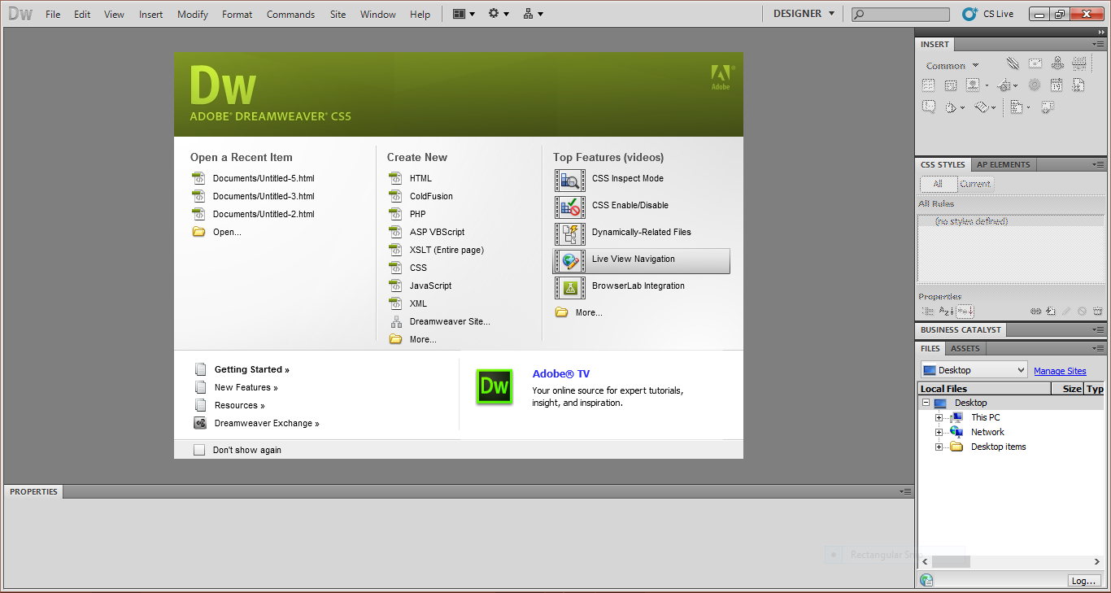

**Fig 4. Adobe Dreamweaver**

**CHAPTER 3**

**Introduction to Online Examination System Project:**

Online Examination System project is used for conducting online objective test, the test will be customized such that system will have automated checking of answers based on the user interaction. This project helps the faculties to create their own test based on the subject. This also helps the instruction to perform online quiz, test paper such that the academic performance of the students can be increased and can take the feedback from both students and parents.

While a faculty creates their test paper he has given the permission to add the students who are supposed to write the exams, such that he can conduct test paper to students of different class, so that no student gets a question, different from the syllabus. The results of the exam he had conducted is available to him after the student writes is online examination. All students, faculty, parents, etc. has separate login to this project. Some of the main features of this projects are: it reduces the paper work for the faculty, creates automatic response to the students, such that he can get result weather the answer given by him is correct or not, can generate reports after the examination and can be handover to parents such that they can see the status of his child. Administrator has given the supreme power to add faculty and to manage the entire site. Unregistered users cannot able to attend the online examination, but in future scope there will be an option for this too.

**Value of Online Examination System Project:**

**Value to Administration:**

* Control over resources and tools to ensure optimum utilization of resources.
* No redundancy of work/data entry with centralized database system.
* Manage the daily substitutions efficiently and effectively.

**Value to Teachers:**

* Get rid of mundane clerical tasks like calculating percentages of marks and individual tests and marks etc.

**Value to Students:**

* Never lose any information about the school notice and tests.
* No redundancy because specific user id’s are available to all students in order sit in the exam and in order to check out their results.

**Comparison between Online exam and Paper based**

|  |  |  |  |
| --- | --- | --- | --- |
| **S. No.** | **Parameter** | **Online Exam** | **Paper Based Exam** |
| **1** | **Security of Examination Paper** | Online exam provides flexibility and security for question paper as each student can get random questions of same exam pattern. | It is not possible to set different exam paper for different student and there are chances of leakage of exam paper while passing it to different examination centers. |
| **2** | **Result Processing** | Online Examination Results are instant and accurate | In case of paper based exam overheads associated with verification of answers and result processing are huge and prone to errors |
| **3** | **Examination Center** | Online Exam can be conducted where candidate can appear for it from remote examination centers with web camera surveillance technique. So hundreds or thousands of students can appear for it from various locations | In case of traditional exam, management of examination includes classroom infrastructure, question paper, answer sheets |
| **4** | **Logistic** | Logistic cost is minimum | Logistic cost is high |
| **5** | **Subjective Questions** | Online Exam can have limitations for subjective exams like drawing, diagrams | No such limitations for paper based exam. |
| **6** | **Per Examination Cost** | Due to flexibility of online examination cost per candidate can be around Rs. 50 to Rs. 150 including examination center cost. | Paper based exam would cost more than Rs 300 to Rs. 400 per candidate. |
| **7** | **Supervisor** | Online Exam can be managed in auto surveillance mode where web camera connected to the system would take snapshot of the student appearing for the exam. This would ensure that same student is appearing for the exam and system is able to keep track on student during exam. | For each designated set of students supervisor is required. |

**CHAPTER 4**

**Modules of Project**

The modules one is master and it consists of nine forms and they are as follow:

* Admin
* User

The module admin contain following forms:-

* Login
* Add test
* Add subject
* Add question

The module user contain following forms:-

* User login
* Subject for quiz
* Result

**Admin module:** This module contains following forms:

1. **Administrative login:**- In this form admin can be login through their specifics login ID and password in order to maintain the security. Administrators are basically the teachers.
2. **Add test:**-In this form administrators can set or add the test according to subjects Id, test name and with total number of questions of test.
3. **Add subject:**- In this form administrators can set or add the subject.
4. **Add question:**- In this form administrators can add the numbers of questions according to particular tests along with options and with the true answers of the questions.

**Second module is USER**: This module consists of three forms and they are as follow:

1. **Create Student(user)login id and login** :- In this form we fill the information about the student like name, gender, class, section, father’s name, mother’s name, parent’s contact, address etc. which is also viewed in the form of a table below the form from where it can be deleted and edited.
2. **Subject for quiz:-** In this form students will choose the subject which is choosen by them for quiz.
3. **Result:**- In this form students will the see the results of their quiz exams which are shown as according to the exams given by the students.

**CHAPTER 5**

**TABLE STRUCTURE**

**Admin login and registration**

**DESCRIPTION:** **This table will contain the data regarding the registration of different admin of the software.**

Capture1

**User login**

**DESCRIPTION:** **This table will contain the data regarding the registration of different users of the software.**

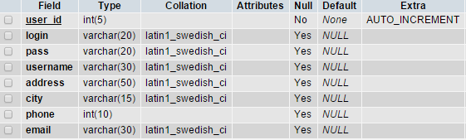

**Add Test**

**DESCRIPTION:** **This table will contain the data regarding tests that can be taken during the quiz.**

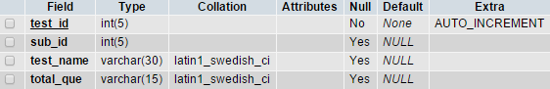

**Add Subject**

**DESCRIPTION:** **This table will contain the data regarding the subjects of quiz.**

Capture7

**Add Question**

**DESCRIPTION:** **This table will contain the data regarding the questions of the tests and subjects.**

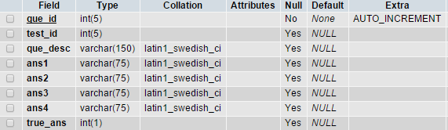

**User answer**

**DESCRIPTION:** **This table will contain the data regarding the answer of users.**

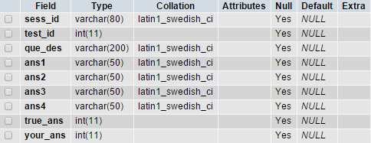

**Result**

**DESCRIPTION:** **This table will contain the data regarding the results of students according to their tests.**

Capture7

**CHAPTER 6**

**DATA FLOW DIAGRAM**

Level 0 DFD

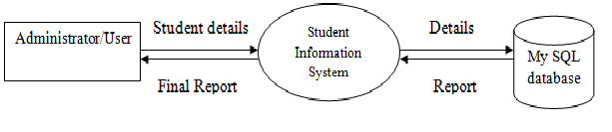

Level 1 DFD

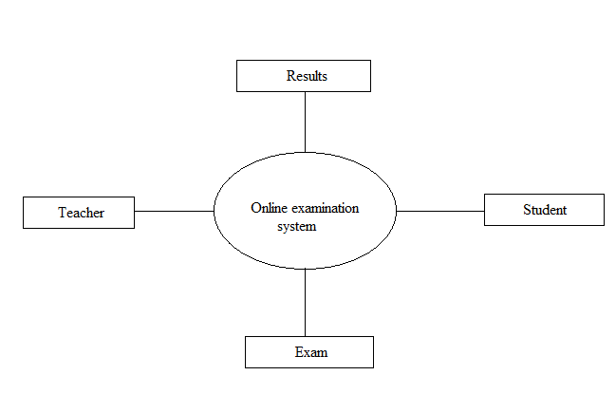

Level 2 DFD

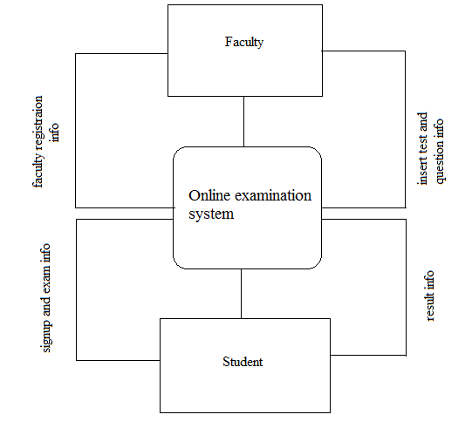

**ER DIAGRAM**

ADMIN

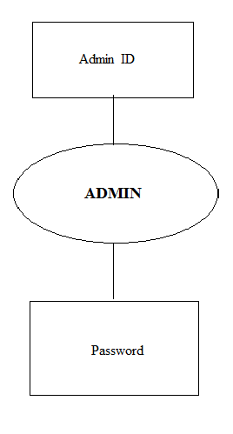

USER

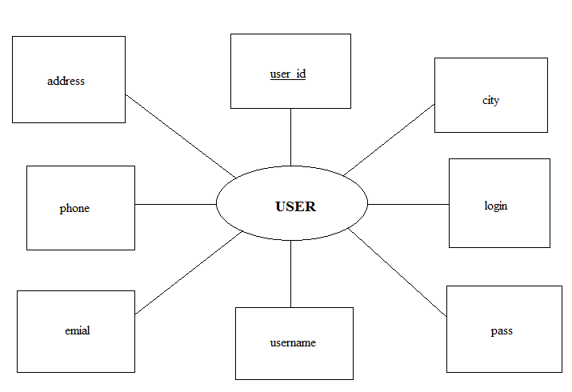

SUBJECT

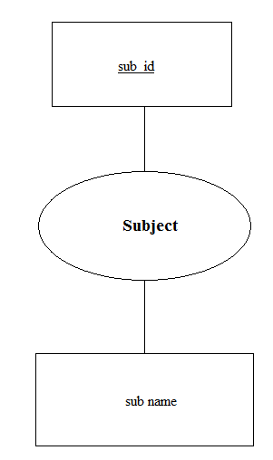

QUESTION

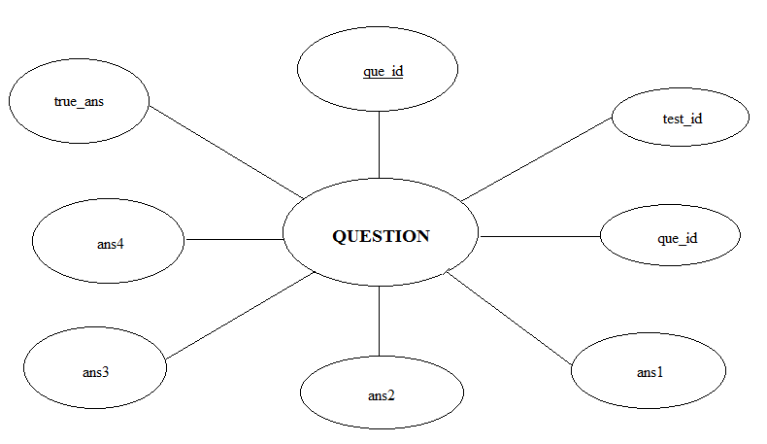

TEST

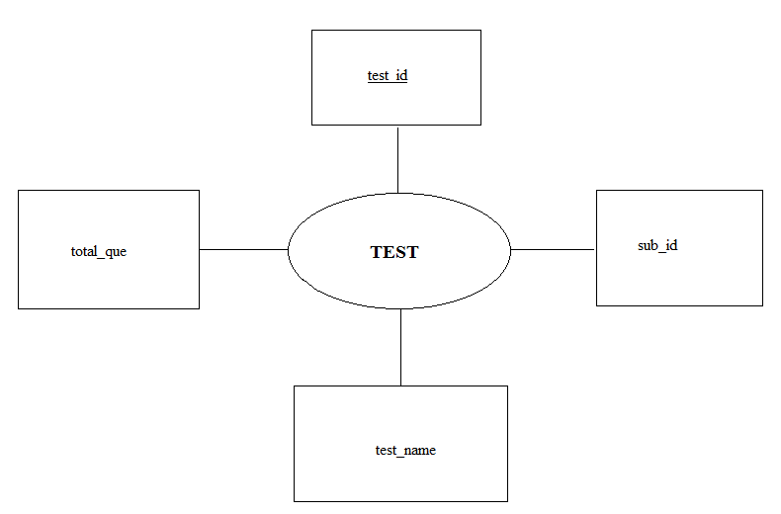

RESULT

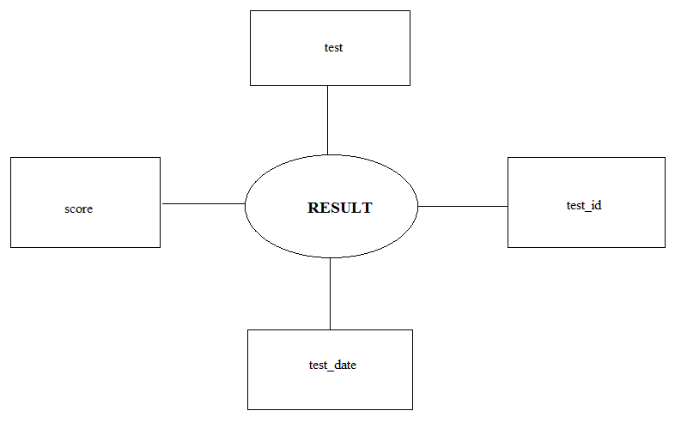

**CHAPTER 7**

**SNAPSHOTS**

ADMIN LOGIN OR HOME PAGE

.

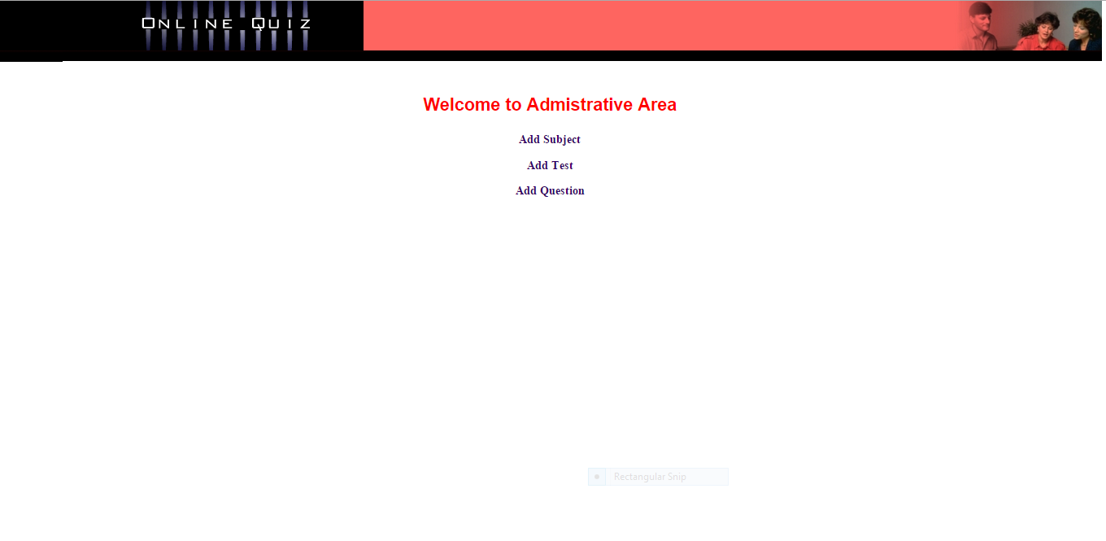

ADD SUBJECT

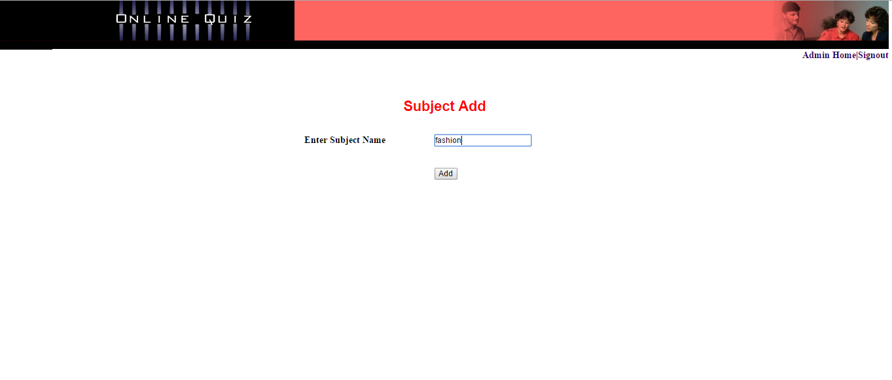

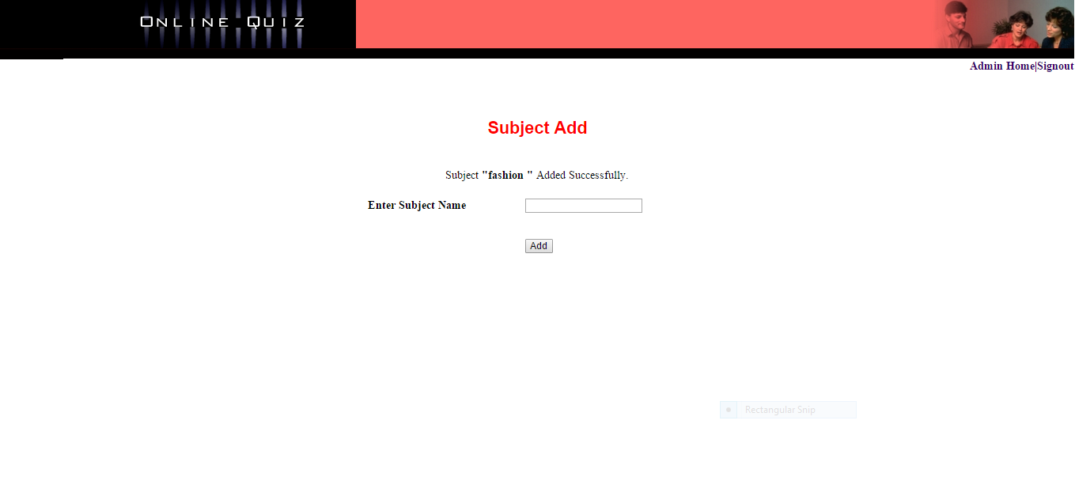

ADD TEST

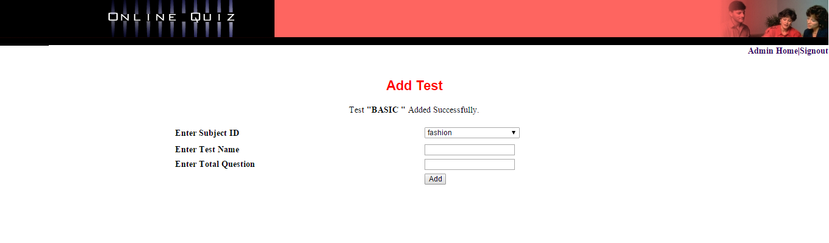

ADD QUESTION

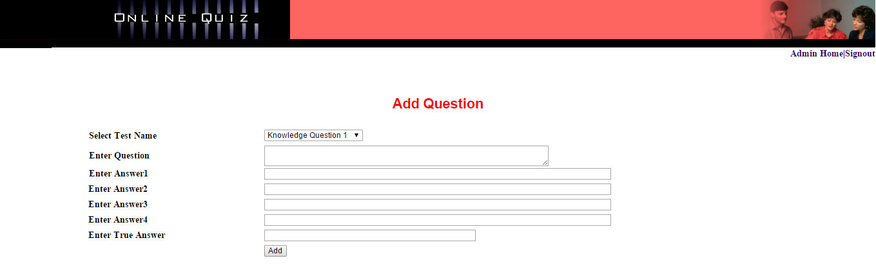

USER LOGIN FORM

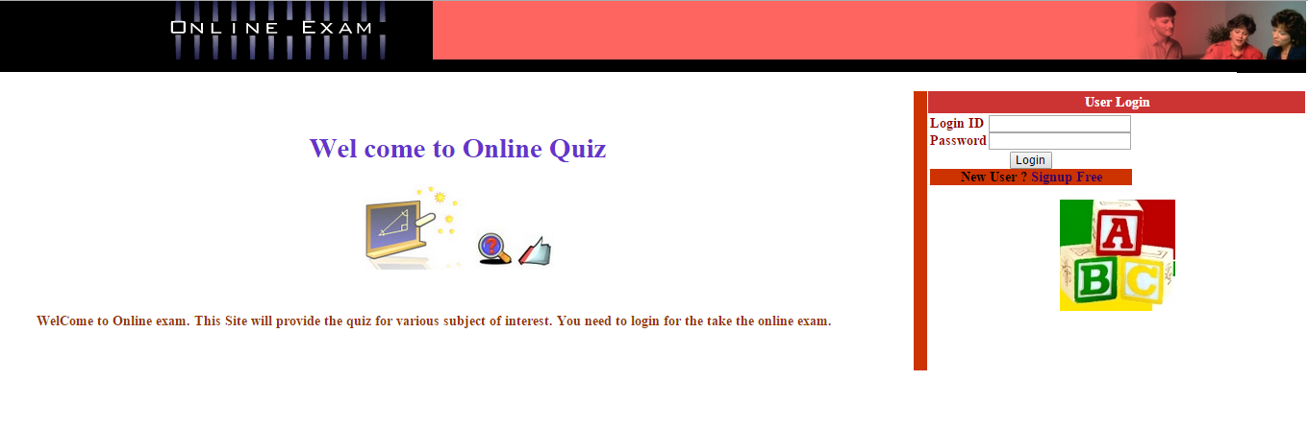

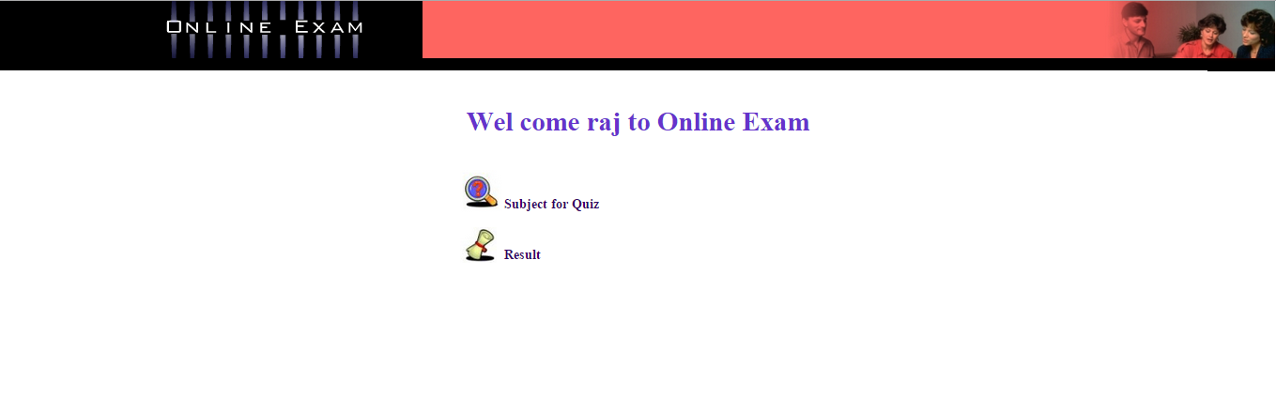

SUBJECT FOR QUIZ

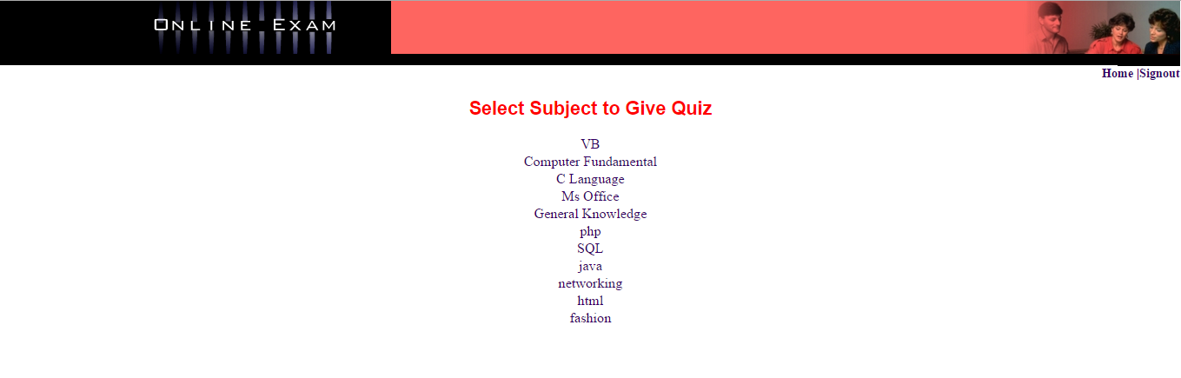

RESULTS

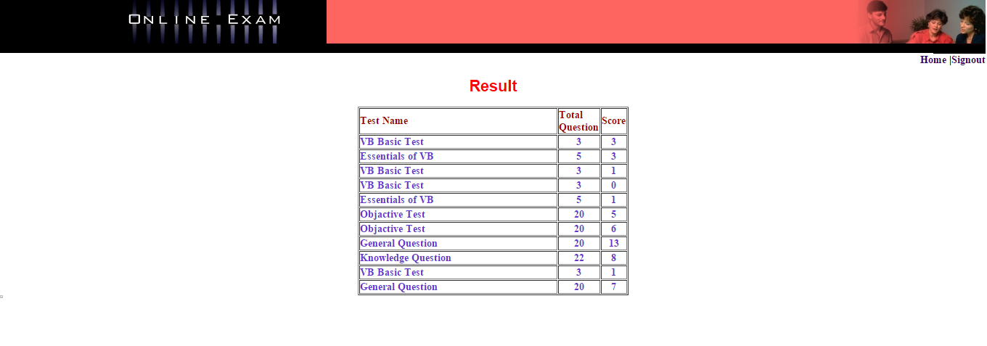

**CHAPTER 8**

**CONCLUSION**

**ONLINE EXAMINATION** system is developed for efficient information retrieval and records maintenance. The software may not be very sophisticated and may have a number of discrepancies in it, but it has paved a way in software development.

All the modules and procedures are made simple in order to make the system self-explanatory. All the specified objective of the system is achieved through the complete analysis, proper design and development of system. Our project uses the advanced technology offered by the computerization. It reduces the chances of errors, decreases the hectic calculations and also eliminates the need of manpower to some extent. The system was verified with valid as well as invalid data in each manner.The results obtained were fully satisfactory from the user point of view**.** The system is run with an insight into the necessary modifications that may require in the future.

**Main advantages are:-**

**Cost effective:**

Substantial cost reduction in the expenses of conducting an exam:

1. No Printing or Distribution Expenses for question papers.
2. No transport and logistics expenses while conducting exams across several

geographically scattered locations.

**Secured Exams:**

1. Maintain confidentiality and avoid paper leaks.
2. Change question papers at the last minute by pulling questions from the

Question Banks.

1. No data loss even in situation of power and internet failure

**Expand your Scope:**

1. Create multiple exams on multiple subjects for multiple courses.

**User Convenience:**

1. Users can take exams as per their convenience .Exams can be configured for

24X7 availability.

1. Users can view the exam results immediately after the exam.

**Analysis:**

1. Store data for comparison in subsequent years.

**BIBLIOGRAPY**

1. System Analysis & Design by Awad, Galgotia Publications, 1996

2. Introducing Microsoft php, Second Edition author David S. Platt.

3. Alex Mackey, “Introducing php: With Visual Studio 2010”, Press, USA, 2010.

WEBSITES:-

1. http://www.msdn.php/

2. http://www.projectsgeek.com/

3. <http://www.w3schools.com/php/>

4. <http://www.google.com>

5. http://www.wikipedia.com